Describe different classes and there ranges

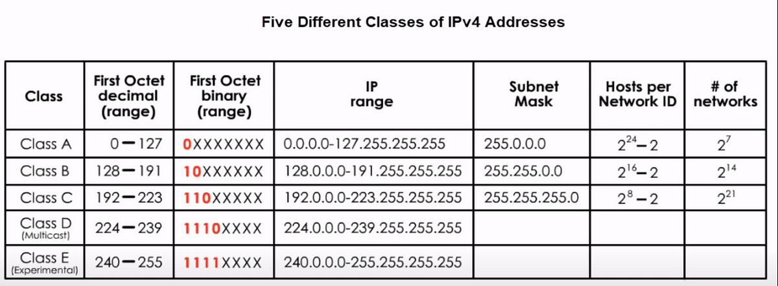

Describe subnetting (fixed and variable length)

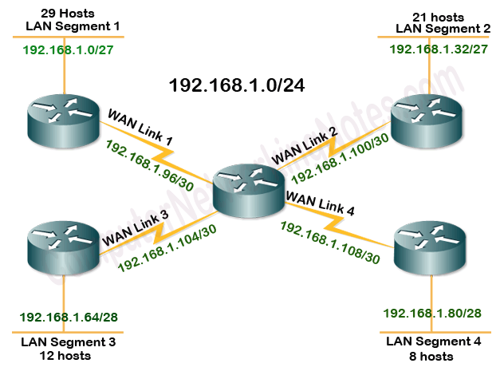

Local routers route within subnet networks

Let us define the normal subnetting concept structure:

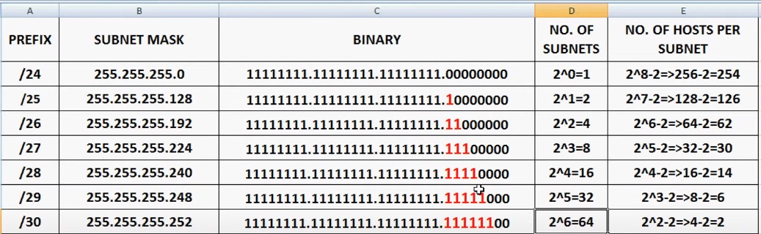

Fixed subnetting

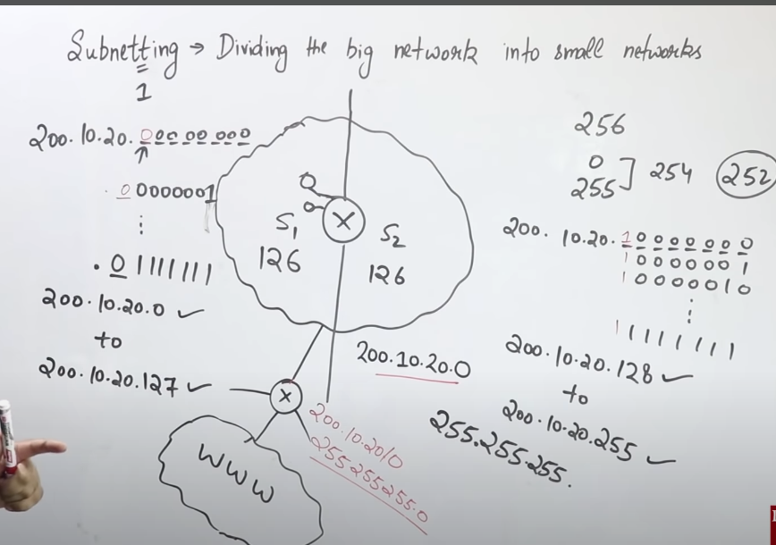

Explain variable length subnetting with example:

